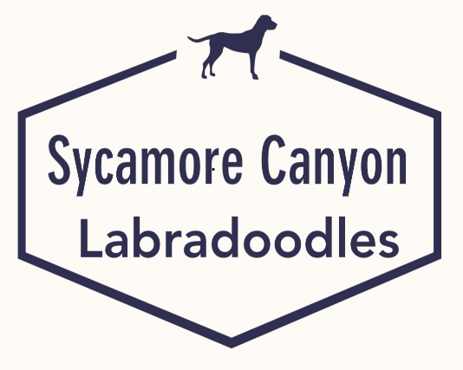

Puppy Sales Contract

Seller Name: Sycamore Canyon Labradoodles
Address: 6059 Speyside Rd., Riverside, CA 92507
Phone: (951) 333-1569

Buyer Name: ______________________________
Address: ____________________________________________________
Phone: __________________________________

Date of Sale: ________________
Date of Delivery: _______________
Price: $3000.00 (plus sales tax)
Deposit: $500.00 Date: _________________
Balance paid: ____________ Date: ________________ (Balance due on delivery)

Description of the puppy or dog

Breed: Multi-Generational Australian Labradoodle
Gender preference: ( ) Male ( )Female
Color: ____________________
DOB: ____________________ (Puppies must be 8 weeks or older before delivery)
Litter/Registration Number: _________________________

Sire: ___________________________________
Call Name: ______________
Registration#_____________________
OFA#: __________________
Dam: __________________________________
Call Name: ______________
Registration# ____________________
OFA#: __________________
*** See pedigree attached.

Proposed use of the puppy or dog

( ) Pet or family companion
( ) Performance competitions

Seller Agreements

- This puppy/dog is a 4th generation Australian Labradoodle. This puppy/dog is of typical temperament and structure and embodies the basic standards of the Australian Labradoodle breed.

- The pedigree furnished is correct.

- The puppy/dog is registered __________ registerable ____________ with the WALA.

- The registered name is/will be _______________________________________; or

- The kennel prefix ______Sycamore Canyon Labradoodle must be used as the first word of the registered name or be used in the name.

- WALA registration papers will be filled out after the sale is complete and will be forwarded to the buyer once WALA returns them.

- The purchase price of this puppy/dog will be refunded if the buyer furnishes the seller with a veterinary certificate indicating that the puppy/dog is unwell or unsound and returned within 72 hours from delivery. The Seller will reimburse no veterinary or shipping costs.

- If the buyer has paid by check, the purchase price will be refunded only if or when the buyer’s check has cleared and been credited to the seller’s account.

- The puppy/dog’s sire and dam are both OFA certified as free of hip dysplasia and comes from many generations of puppy/dogs who are also free of hip dysplasia. The puppy/dog is expected to be free of hereditary crippling hip dysplasia. However, no guarantee of such is or can be made, or intended herein.

- The puppy/dog is healthy at the time of sale and has had immunizations enumerated in the attached health record.

- If at any time the buyer is unable to keep or care for the puppy/dog, it must be returned to the seller. The puppy/dog may not be transferred or sold by the buyer. The buyer’s understanding and acceptance of this condition is signified here by his or her initials: ___________ on ____(date)_______.

The seller will endeavor to place any returned puppy/dog as advantageously as possible. If a purchase price is obtained for the puppy/dog, it will be refunded to the original buyer, less any costs of placement. If the puppy/dog is placed free of charge, no money will be returned to the original buyer. No veterinary or other costs of keeping the puppy/dog, or any other costs incurred by the buyer resulting from his/her ownership of the puppy/dog, will be paid by the seller to the original buyer of the puppy/dog under any circumstances.

- The seller in no way guarantees that this puppy/dog shall win in conformation and/or performance events.

- The seller agrees to provide advice and information on showing and grooming to the best of his/her ability, to help the buyer of a show or performance potential puppy/dog to present the canine to its best potential.

- If the seller determines, by any means, that the puppy/dog is not suitably cared for, or that it has been mentally or physically mistreated, the seller has the right to take full possession of the dog, and its duly signed AKC transfer papers/registration, without compensation.
- All puppies go home spayed or neutered unless otherwise stated.
The seller’s opinion is the only authority required to justify this action. Testimony of other people will not supersede the seller’s judgment on this matter. Under such circumstances, all warranties are then VOID.

No other warranties or guarantees, expressed or implied, are made under this contract except as stated above.
Signed by the seller: __________________________
Date: _________________

Buyer Agreements

The buyer agrees that if at any time, and for any reason, he/she is unable to keep or properly care for the puppy/dog, it shall be returned to the seller and no one else. The buyer’s understanding and acceptance of this condition is signified here by his/her initials: ___________ on _______(date)______.

- The buyer agrees to maintain the puppy/dog’s health with yearly vaccinations as specified by their veterinarian.

- Should the puppy/dog become ill or unsound, all costs of treatment will be the responsibility of the buyer.

- The buyer agrees to keep the puppy/dog in an appropriate lean weight to maximize the puppy/dog’s soundness and longevity.

- The buyer agrees to feed only those puppy/dog foods acceptable to the seller, and, agrees not at any time to feed the puppy/dog a “raw,” beef, vegetable, or home-cooked diet.

- The buyer agrees to contact the seller about any changes to the puppy/dog’s diet and to abide by the seller’s decision regarding any change in food. The buyer’s acceptance of this condition is signified here by his/her initials: __________ on ___(date)____.

- The buyer agrees to socialize, train, and keep the puppy/dog in a manner acceptable to the seller.

- If at any time, the seller finds that the puppy/dog is being kept, treated, or allowed to behave in a manner not acceptable to him/her, the buyer agrees to surrender the puppy/dog to the seller. It shall include all its registration documents, with ownership transfer adequately signed.

- The buyer agrees to allow the seller access to the puppy/dog, and to the premises where it is kept, to evaluate the condition therein.

- The buyer of both pet and show/breeding puppies shall obtain OFA hip certification (Penn Hip is not acceptable) as soon as possible after the puppy/dog reaches 24 months of age. This will help us continue to provide the healthiest, happiest, and soundest pets possible.

- The buyer agrees not to sue the seller and to pay all court or attorney fees incurred by the seller should any suit be brought against the seller regarding this puppy/dog by any person. The buyer signifies acceptance of this condition by initialing here: __________ on ____(date)____.

- The buyer acknowledges that special coat care, conditioning, training, and feeding are necessary to produce a healthy Australian Labradoodle and that this care and training is his/her responsibility.

Special agreements pertaining to the purchase of this puppy/dog are listed below:
- Neutering: ____________________________
- Showing: _____________________________
- Other: _______________________________
Signed by the buyer: ______________________________ on _______(date)______.

***************************
- Witnessed by: ____________________________________________ on this date of ____________ at __________________________.
Address: ________________________________________________
Phone: __________________________________

- Witnessed by: ____________________________________________ on this date of ____________ at __________________________.
Address: ________________________________________________
Phone: __________________________________

